caAERS

Mayo Clinic Cancer Center Adoption Report
(Task 5.5)

DOCUMENT REVISION HISTORY
Version Number | Date | Description
1.0 | 9/23/08 | Final Draft
2.0 | 3/2/09 | Final Version – end of POP
2.1 | 3/4/09 | Final version with S Elcombe, B Andersen, M Carston input

Introduction

Project Overview
The goal of this adoption report is to document the progress of the Mayo Clinic Cancer Center (MCCC) in its plan to implement caAERS as its adverse event management system.

Project Participants and Responsibilities

The MCCC caAERS team consists of Mses. Sharon Elcombe, Sonja Hamilton, Jean Hanson, and Jennifer Frank from the business side. All participated in the caAERS adopter activities since its inception. Brad Andersen and Michael Carston represent the MCCC IT staff. The team is responsible for installing, piloting, integrating/configuring caAERS at the MCCC, and training new users of the system.

Additionally, Robbin Peterson, a MCCC Clinical Research Associate (CRA), Heather Ondler, a MCCC CRA, Patricia McNamara, the MCCC SAE Coordinator and members of the Clinical Trials Management System (CTMS) IT staff, and others, as necessary, will participate in piloting, evaluating, and integration strategy development.

Mayo Clinic IT staff, including IT Security, will be responsible for approving and implementing necessary components for data sharing and ensuring that data sharing on the caGrid is handled appropriately.

Dependencies/Risks

The overall strategy is dependent upon:
- Installation of the Oracle database on an institutional server has been completed
- Installation of a new application server is in process.
- Access to API documentation.
- Access to data models.

Constraints / Issues
- Past and on-going MCCC clinical trials do not routinely collect hospitalization and expectedness on every AE. This will pose challenges for legacy data and on-going trials. The developers are addressing this issue for routine adverse event capture in a future release.
- The current MCCC CTMS will not allow for updates to adverse events via the caAERS mechanism and also via the data entry system. Therefore, we will only be able to instantiate caAERS for studies where MCCC is the data center and the only participant in the study.
- Only studies where the MCCC is the data center can be instantiated, as studies with other data centers may not be defined in the caAERS data base. This may change as the product is instantiated across the Cooperative Group system.
- Because MCCC does not currently have a Tomcat server available in the DMZ, we will not be able to use caAERS as the point of entry for studies that use our remote data capture system outside of our firewall e.g. NCCTG studies.
- Data Sharing will be constrained by institutional and MCCC policy and the ability to implement those policies in the caGrid security environment.

Project Plan
Pre-Pilot:
The MCCC performed a pre-pilot of caAERS on three on-going studies where the MCCC is the data center. This pilot assessed both the AE data collection and AEs requiring AdEERS reporting. The studies and patients were imported from the MCCC CTMS and AEs added manually.
Pilot
The MCCC will perform a pilot test of caAERS on 22 selected studies in three phases.
Step 1) MCCC will enter 3 – 5 previously submitted AdEERS reports via the caAERS application and compare the reports. This will be done on a few studies selected by the developers.
Step 2) MCCC will test caAERS in parallel with AdEERS
Step 3) At the point that the application is deemed ready for production testing, we will use the caAERS application as the front end for the AdEERS system for the identified studies.
Based upon the pilot outcome a decision will be made regarding how caAERS should be instantiated into the Mayo CTMS system.
Final Update: Step 1 is completed and step 2 is in progress. Documentation of testing and results can be found at https://wiki.nci.nih.gov/display/CTMS/Mayo+Pilot.
There are several issues that must be resolved before the MCCC can implement caAERS as a front end for the AdEERS system. They include:
- Ability to modify AdEERS reports
- CTEP approval
- Determination as to whether affected protocols need to be modified
- Successful parallel testing of 25 AdEERS reports (or 8 weeks worth of reports)
Additionally, while the MCCC would be able to implement caAERS as the AdEERS front end for the 22 studies in the system, there currently is not a scalable mechanism for inputting and maintaining CTEP Enterprise data needed for AdEERS. We are currently loading this information from a spreadsheet. This is a critical need and will keep us from full implementation. The new Enterprise Services (COPPA) may resolve this situation.
Integration: The intention at this point is that the MCCC will use caAERS as the front end for AdEERS reporting. When the caAERS user interface is user accepted and fully tested, we will evaluate how we might integrate caAERS with our CTMS. How caAERS will interact with the new CDMS will also affect the plan.
Final update: The MCCC installed 6 versions of caAERS over the period of performance.
The MCCC CTMS and caAERS integration architecture can be seen in Figure 1. Several integration steps were accomplished:
- Data from the CTEP Enterprise database on twenty-four studies were loaded into caAERS via the caAERS CTEP Excel Loader. This included study, investigator, agent, and treatment assignment code (TAC) information.
- Patient data were loaded into caAERS from the MCCC CTMS system for all of the patients enrolled on these twenty-four studies. The patients were loaded into caAERS using the patient import facility within the user interface. The XML data were generated in batches, using code that formats the XML files specifically for the patient import facility. Eventually, this code can be readily adapted to automatically push patient data to the caAERS message service upon patient study enrollment. (See "Integration Plans" below.)
Integration Plans for using caAERS as the front end for AdEERS include the following:
- Prerequisites:
  - ability to electronically access staff and CTEP protocol information from the NCI systems
  - CTEP approval of using caAERS as a front end to AdEERS
  - ability to modify AdEERS reports via caAERS
  - successful parallel testing
- Integration steps:
  - Load protocol information from MCCC CTMS that is required for data entry (not AdEERS reporting). This process will be fleshed out as the electronic access to the CTEP Enterprise data is defined.
  - Ideally, we would like to have the patient registration and study records load instantaneously from a database trigger, however, a periodic “batch” process could also be used (see Appendix A for Technical Integration notes). The planned patient data live feeds are displayed in Figure 2.
Data Sharing: Based on lessons learned during the caAERS construction and transition phases, a data sharing plan will be developed that will consider institutional policies, technical infrastructure, and security.
Final Update: Data sharing will be more fully addressed as there are data to share and the security and associated processes are in place. We are working with DSIC and others to recommend and define a data sharing process that would be attainable – some first steps. This might include sharing de-identified AE data on published studies. Certainly, it would be helpful to leverage the CRF data items that have already been defined and agreed upon.

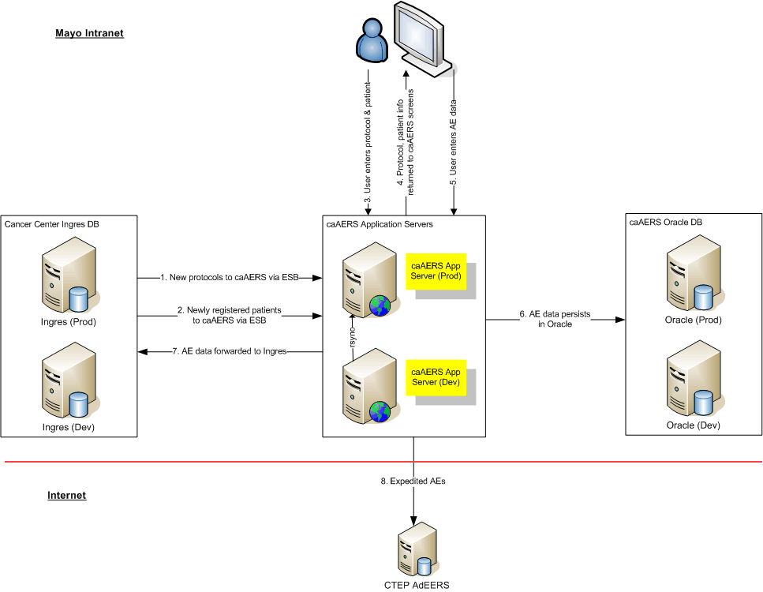

Figure 1

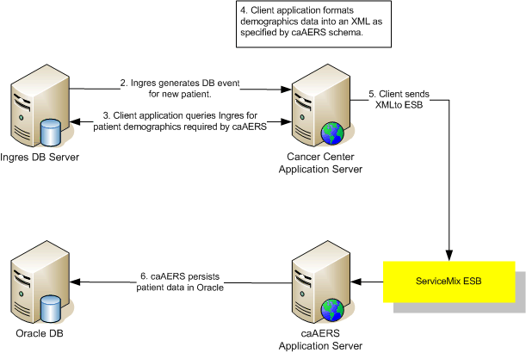

Figure 2

Appendix A

caAERS
Adoption Plan
Technical

Technical Integration
Transition to Oracle db and Apache running on Linux
We are working on the transition. Our Oracle instance has been created. Once we get our new application server up and running we will transition to Oracle. There are some open questions about what if any data we will port over to Oracle.

Automating CTMS to caAERS patient load
The current version of caAERS has the ability to receive patient information via web services. There is a new and update service. It is our plan to automate the loading of patient data into caAERS. Our goal is to add new patients soon after they have completed the registration process.

We have identified two ways to proceed with automating patient loads into caAERS. One option would be to setup a CRON job to run at some interval. This job would gather all the new registrations since the previous run, build the xml file and pass to the CREATE_PARTICIPANT service. We would add a failure notification into the job to keep us alerted to any issues. Our second option is to add a trigger to our database that fires when a patient is added to a study that is also in caAERS. The trigger event could call the same or a very similar program that is mentioned for option one. The one major difference between these two options is that the CRON job would act more like a batch load and could include multiple records. The trigger would be on single entry and send a single record at a time.

At some point we need to identify changes to the patient record and pass those changes to caAERS, if warranted. Those rules need to be defined. This process would probably require a database trigger.

Automating CTMS to caAERS study load
The current version of caAERS does not have the ability to push data out to a local CTMS system. Once the caAERS team implements this feature we will look into making the connection to our CTMS system.

